Accounting Period Control & Closing Process in NetSuite
Accounting Periods, Locking vs. Closing, the Period Close Checklist, Quick Close, Reopening Periods, Year-End Closing, and SuiteScript Access to Period Status
Weekly Learning Series — Week 24

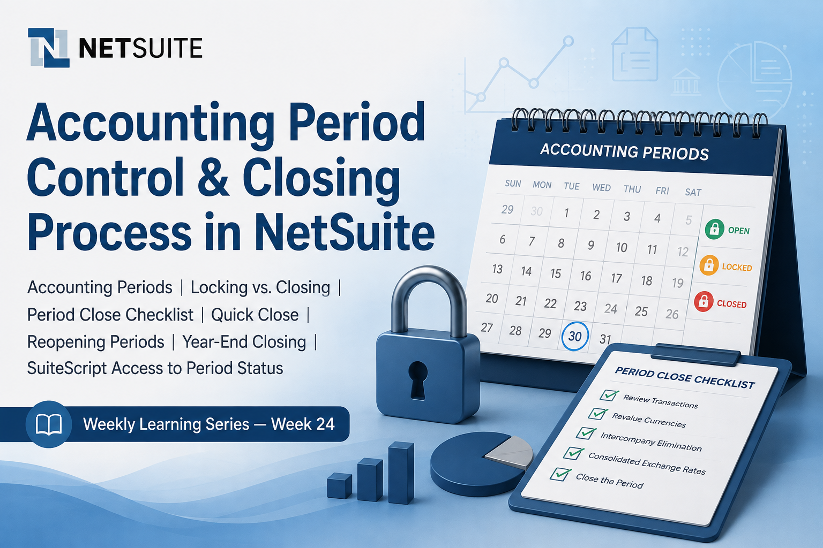

1. Introduction
Week 23 looked at Multi-Currency and Foreign Currency Revaluation — a cross-cutting layer of NetSuite Accounting that becomes a required, manually triggered task at month end. That naturally raises the question this week answers: what actually governs when a month is “at month end,” who is allowed to still post to it, and what stops a closed month from ever being touched again? The answer is the Accounting Periods feature, together with the Period Close Checklist that drives every period from open, through progressively locked, to fully closed.
Accounting Periods are the structural backbone every other close-process feature plugs into — currency revaluation, intercompany elimination, consolidated exchange rates, revenue recognition, and GL audit numbering are all Period Close Checklist tasks that ride on top of the period record itself. This document covers how periods are set up and locked, the distinction between locking and closing, how the Period Close Checklist sequences the required tasks, Quick Close, reopening a closed period, year-end closing, and how SuiteScript 2.1 can read period status to gate scheduled processing.

📌 Why Period Control Isn't Just a Month-End Checkbox
- Locking and closing are two different controls: locking (A/P, A/R, Payroll, or All) is a preliminary, reversible restriction that only blocks ordinary users, while closing is the final step that blocks posting for anyone, including administrators, until the period is explicitly reopened.
- The Period Close Checklist isn't a static form — its task list changes based on which features are enabled (Multiple Currencies, OneWorld, Advanced Revenue Management, GL Audit Numbering, Multi-Book Accounting), and every previous period must already be closed before the current one can be.
- Reopening a closed period is not an isolated action — it automatically reopens every later period that was already closed, all of which then need their checklist tasks redone before they can close again.

2. Accounting Period Fundamentals — Setup, Hierarchy, and Permissions
When the Accounting Periods feature is disabled, NetSuite transactions post to the general ledger in real time with no period-level control. Enabling the feature lets users select a past or future posting period on each transaction and lets accounting staff monitor and control the status of periods as a discipline in itself. If historical data already exists, the feature can still be enabled — an accounting period is then created for the past quarter or month, and NetSuite automatically assigns existing transactions dated within that range to it.

2.1 Enabling the Feature and Building the Period Hierarchy
Step | Where | Notes
Enable Accounting Periods | Setup > Company > Enable Features, Accounting subtab | Requires the Enable Features permission. If you don't use OneWorld, the feature can't be disabled once an accounting period exists — every created period must be deleted first.
Set up a full fiscal year | Setup > Accounting > Manage G/L > Manage Accounting Periods > Set Up Full Year | Best-practice path — generates the year, its quarters, and its months as one rollup in a single pass, using Calendar Months, 4 Weeks, or 4-4-5 Weeks.
Set up periods manually | Manage Accounting Periods > New Year Only / New Quarter Only / Base Period | The year period must be created first (it's the top of the rollup), then its subperiods — every day must belong to a period for reporting accuracy.
Use fiscal calendars (OneWorld) | Setup > Accounting > Fiscal Calendars | Lets different subsidiaries use different accounting period rollups when the Multiple Calendars feature is enabled; the base periods that roll up into those hierarchies stay common to all subsidiaries.

2.2 Permissions Governing Accounting Periods
- Edit or Full level of Manage Accounting Periods is required to set up, edit, lock transactions for period close, or reopen accounting periods; View level only allows seeing the Manage Accounting Periods page.
- Override Period Restrictions is required to add or make general-ledger-impacting changes to posting transactions in a period that has been locked to that transaction type.
- Completing Period Close Checklist tasks — automated intercompany adjustments, currency revaluation, consolidated exchange rate calculation — needs both of the permissions above, plus each task's own specific permission.
- Allow Non-G/L Changes (a Setup permission) permits edits to posting transactions in a locked or closed period only when the change doesn't affect the general ledger and the Allow Non-G/L Changes box is checked on the period record.
- Non-posting transactions — sales orders, return authorizations, and similar records — aren't subject to any of these period restrictions at all.

3. Locking vs. Closing — and the Accounting Period Window
NetSuite treats locking and closing as two distinct, sequential controls over the same period, and conflating them is one of the more common process gaps in a close cycle.
Control | What It Restricts | Who's Still Blocked
Lock A/P / Lock A/R / Lock Payroll / Lock All | Preliminary, per-transaction-type restriction — a pre-closed state that lets a period's financials be balanced before final close | Ordinary users only — a role with Override Period Restrictions can still post
Close | Final step after account review and reconciliation; prevents posting to the general ledger for any date in the period | Everyone, including administrators — the period must be explicitly reopened before any GL-impacting change can be made

3.1 The Accounting Period Window — Period Wall and Locking Rules
The Enable Accounting Period Window preference maintains a minimum number of unlocked current and future periods (the Minimum Period Window Size, 1 to 1,000) so that periods aren't locked prematurely and users aren't left without an open period to post to. The period wall is the end of the current accounting period — periods to its right are future, periods to its left are current and past. Locking follows four rules relative to that wall:
- Locking a future period automatically locks all future periods after that locking point.
- Locking a past period automatically locks all past periods prior to that locking point.
- Unlocking a future period automatically unlocks all periods between the period wall and the unlocking point.
- Unlocking a past period automatically unlocks all periods between the period wall and the unlocking point.
A period within the current minimum period window can't be locked at all — for example, with a window size of 3 and January as the current period, February and March can't be locked. Locked future or past periods must also stay continuous, without gaps, from the locking or unlocking point.

⚠️ Locking Without the Period Window Preference
- It's possible to lock future periods and transaction types without ever checking Enable Accounting Period Window — but doing so locks all periods or transaction types prior to that point, including the current period, which is rarely the intended outcome.
- Future locked periods created this way also don't display the usual lock icon in the UI, which can make the locked state easy to miss during review.

4. The Period Close Checklist
Every accounting period has its own Period Close Checklist, opened from the Checklist icon on the Manage Accounting Periods page. Tasks are listed in the order they must be completed, and previous periods must already be closed before the current period's remaining tasks — including Close itself — become available; only the locking tasks can be done ahead of that.
Checklist Task | Appears When | Key Permission
Lock A/R, Lock A/P, Lock Payroll, Lock All | Always (Payroll only if the Payroll feature is enabled) | Edit/Full Manage Accounting Periods
Resolve Date/Period Mismatches, Review Negative Inventory, Review Inventory Cost Accounting, Review Inventory Activity | Inventory feature enabled (last item is OneWorld-specific) | Task-specific inventory permissions
Review Custom GL Plug-ins Executions | Custom GL Lines Plug-in in use with async accounts | Review Custom GL Plug-ins Executions + Override Period Restrictions
Create Intercompany Adjustments | OneWorld with automated intercompany expense adjustments enabled | Journal Entry + Override Period Restrictions
Revalue Open Foreign Currency Balances | Multiple Currencies enabled | Currency Revaluation (Create) + Override Period Restrictions
Recognize Revenue / Reclassify Revenue | Advanced Revenue Management (Essentials) enabled | Task-specific ARM permissions
Calculate Consolidated Exchange Rates | OneWorld with multiple base currencies | Currency + Override Period Restrictions
Eliminate Intercompany Transactions | OneWorld with intercompany elimination enabled | Task-specific elimination permissions
Create Period End Journals | Period End Journal Entries feature enabled | Journal Entry + Override Period Restrictions
GL Audit Numbering | GL Audit Numbering feature enabled; required only in the last month of the period | GL Audit Numbering permission
Close | Always — the final task | Edit/Full Manage Accounting Periods + Override Period Restrictions

📌 Reviewing a Checklist Task Isn't the Same as Completing the Underlying Process
- For several tasks — Create Intercompany Adjustments, Revalue Open Foreign Currency Balances, Recognize/Reclassify Revenue — NetSuite only requires that the relevant page has been reviewed before the task can be marked complete; it's technically possible to mark it complete without actually running the process.
- Oracle documentation is explicit that doing so is not recommended — skipping the underlying process (rather than just the checklist formality) leaves the period's financials incomplete even though the checklist shows green.

5. Closing, Quick Close, and Reopening a Period

5.1 Closing a Period
Closing changes a period's status from Open to Closed, which prevents posting to the general ledger for any date in that period, by anyone. It should always be the final step, taken only after accounts have been reviewed and reconciled — not a routine housekeeping click. With Multi-Book Accounting, each accounting period can be closed and reopened per accounting book, chosen through the Filters section on the Manage Accounting Periods page, independently of other books; this is the Extended Accounting Period Close Process feature.

5.2 Quick Close
Quick Close lets one or more accounting periods be closed with a single click, marking every checklist task complete without actually running the underlying period-close processes — it is explicitly a shortcut for organizations certain no period-closing tasks are actually required, not a substitute for the checklist. It's granted automatically to administrators; other roles need the Period Closing Management permission plus the Allow Quick Close of Accounting Periods preference enabled at Setup > Accounting > Accounting Preferences.
⚠️ Quick Close Is Capped at Five Periods per Run
- Attempting to close more than five open periods in a single Quick Close run can make the system unresponsive and cause the process to fail — periods should be closed in batches of five or fewer.
- Example: to close January through September 2025, first run Quick Close with Period to Close = May 2025 (closes January–May), then run it again with Period to Close = September 2025 (closes the remaining four).

5.3 Reopening a Closed Period
Reopening requires the Manage Accounting Periods permission and is done from the Close task's arrow icon on the Period Close Checklist, followed by a required Justification entry that's saved as a user note. Reopening cascades: any later periods that were already closed are automatically reopened too, and their checklist tasks — including Close — need to be redone before they can close again. If a period record has Allow Non-G/L Changes checked, changes that don't affect the general ledger can still be made without a full reopen, provided the user holds the Allow Non-G/L Changes setup permission.

6. Year-End Closing
Year-end closing transfers net income to retained earnings (or owner's equity) and marks the end of posting opportunity for the year's sub-ledgers and general ledger. NetSuite doesn't require a journal entry to close the income statement to retained earnings — two approaches exist, and Oracle strongly recommends the first:
Approach | How It Works | Recommended
Automatic Close | NetSuite calculates cumulative net income through the selected reporting period and displays it in the retained earnings account for reporting; no balance is actually posted, so prior-period income statements remain viewable rather than zeroed out. | Yes — strongly recommended
Manual Close | Journal entries are created to zero out income and expense accounts and transfer the balance to a retained earnings account, starting the new fiscal year at zero net income. | No — not recommended; Period End Journal Entries is the suggested alternative if manual GL entries are unavoidable at year end

Before year-end close, every period in the year should already be closed via its own Period Close Checklist, and open currency balances revalued for each period beforehand if Multiple Currencies is in use. NetSuite automatically performs year-end closing once every period in the year has been closed — there's no separate year-end action required beyond that.

7. SuiteScript 2.1 — Reading Accounting Period Status
The accounting period record (internal ID accountingperiod) becomes available to SuiteScript once the Accounting Periods feature is enabled. It supports custom fields and is primarily read/search-oriented from script — periods are normally created and closed through the UI's own workflow rather than scripted end-to-end. The closed field reflects whether a period is fully closed; if the Extended Accounting Period Close Process feature is enabled for Multi-Book Accounting, that field reflects closure across all accounting books, which is a behavior change worth checking for in any script written before that feature was turned on.

7.1 Gating a Scheduled Script on Period Status Before Posting
A common pattern is checking whether a transaction's posting period is still open before a scheduled or Map/Reduce process attempts to create a GL-impacting record against it, rather than letting the submission fail.
/** SuiteScript 2.1 — Scheduled Script: Skip Posting to a Closed Accounting Period
* Oracle Ref: Accounting Period record (accountingperiod), Accounting Period Close
* Note: with the Extended Accounting Period Close Process feature (Multi-Book),
* the "closed" field reflects closure across all accounting books — see
* SuiteScript Impact of Extended Accounting Period Close Process Feature.
*/
define(['N/record', 'N/search', 'N/log'], (record, search, log) => {

function isPeriodClosed(periodId) {
const period = record.load({ type: 'accountingperiod', id: periodId });
return period.getValue({ fieldId: 'closed' }) === true;
}

function findOpenPeriodForDate(txnDate) {
// Returns the internal ID of the base period whose date range contains txnDate
// and whose closed field is false; adjust filters for OneWorld fiscal calendars.
const periodSearch = search.create({
type: 'accountingperiod',
filters: [
['startdate', 'onorbefore', txnDate],
'AND', ['enddate', 'onorafter', txnDate],
'AND', ['closed', 'is', 'F'],
],
columns: ['internalid', 'periodname'],
});
let result = null;
periodSearch.run().each((r) => {
result = r.getValue({ name: 'internalid' });
return false; // first match only
});
return result;
}

function execute(scriptContext) {
const journalId = /* resolved elsewhere in the process */ null;
const targetPeriodId = /* the period the pending journal targets */ null;

if (isPeriodClosed(targetPeriodId)) {
log.audit({
title: 'Skipped posting — period closed',
details: 'Target accounting period ' + targetPeriodId + ' is closed; ' +
'record the exception for manual review rather than resubmitting.',
});
return;
}

// Safe to proceed — create/submit the posting transaction here.
}

return { execute };
});

⚠️ Don't Rely on Script to Bypass Period Restrictions
- A script running under a role without Override Period Restrictions still fails to post into a locked or closed period, exactly as the UI would enforce — checking the closed field lets a process skip and log the exception gracefully instead of throwing an unhandled error.
- Confirm the exact behavior of the closed field for the account's edition (single-book vs. Extended Accounting Period Close Process) in the SuiteScript Records Browser before relying on it in a production script.

8. Architect's Quick Reference — Accounting Period Control Decision Framework
Design Decision | Recommended Approach
Preventing routine users from back-posting during month-end review | Use Lock A/P / Lock A/R / Lock Payroll / Lock All as the pre-close step — it blocks ordinary users while still letting a role with Override Period Restrictions post if genuinely needed.
Maintaining enough open periods without manual monthly upkeep | Enable the Accounting Period Window preference with a sized Minimum Period Window Size rather than manually locking/unlocking each month.
Sequencing month-end tasks | Work the Period Close Checklist in order — previous periods must be closed before the current period's remaining tasks, including Close, become available.
Closing several already-closed periods after a correction | Use Quick Close in batches of five or fewer periods rather than one large run, to avoid an unresponsive process.
Reopening a period for a correction | Expect the cascade — every later closed period reopens too and needs its checklist redone; document the Justification text since it's retained as a user note.
Zeroing income and expense accounts at year end | Prefer Automatic Close; avoid Manual Close journal entries unless unavoidable, and use Period End Journal Entries instead if GL entries are required.
Reading period status from SuiteScript | Load or search the accountingperiod record's closed field rather than assuming based on date — and account for Extended Accounting Period Close Process changing what that field means for Multi-Book accounts.
Editing a posting transaction after its period closes | Reopen the period rather than looking for a workaround — no one, including administrators, can make GL-impacting changes to a closed period without it, except non-GL changes explicitly permitted on the period record.

📌 Week 24 Learning Summary — Accounting Period Control & Closing Process
- Accounting Periods, once enabled, replace real-time posting with a controlled period hierarchy (year, quarter, month) that every other close-process feature — revaluation, revenue recognition, consolidated exchange rates, GL audit numbering — plugs into as Period Close Checklist tasks.
- Locking (A/P, A/R, Payroll, All) is a reversible, pre-close restriction that blocks only ordinary users; closing is the final, cross-the-board restriction that even administrators can't bypass without reopening the period.
- The Period Close Checklist's task list is dynamic — it grows or shrinks based on which features (Multiple Currencies, OneWorld, Advanced Revenue Management, GL Audit Numbering) are enabled, and previous periods must already be closed before the current one's tasks unlock.
- Quick Close marks checklist tasks complete without running the underlying processes and is capped at five periods per run — it's a shortcut for certainty, not a substitute for the checklist.
- Reopening a closed period cascades to every later closed period, which then needs its own checklist redone — reopening is never an isolated, single-period action.
- Year-end closing needs no separate action beyond closing every period in the year; Automatic Close is the strongly recommended method over manual zeroing journal entries.
- SuiteScript reads period status through the accountingperiod record's closed field via N/record or N/search — behavior differs once Extended Accounting Period Close Process is enabled for Multi-Book Accounting, so that distinction should be confirmed per account before scripts depend on it.
- This document intentionally keeps to the publicly documented Oracle NetSuite accounting period and close-process architecture and does not reference any organization-specific configuration.

